**Document Bug Reports**

**Website Testing**

1. Manual Testing

Dokumen test case : <https://bit.ly/3yuTNnB>

Bug Reports :

| Scenario | Number of TC | Pass | Failed | Pending | Notes |
| --- | --- | --- | --- | --- | --- |
| Authentication | 14 |  |  |  |  |
| - Register | 7 | 1 | 6 | - | All negative test cases not as expected |
| - Login | 6 | 6 | - | - | As expected |
| - Logout | 1 | 1 | - | - | As expected |
| Home Page | 3 | 2 | 1 | - | Filtering item by category not working |
| Cart | 4 | 3 | 1 | - | Unable to display automatic item data on transaction page |
| Transaction | 7 | 1 | - | 6 | Transaction data is not registered directly automatically, this feature depends on transaction data |

1. Automation Testing

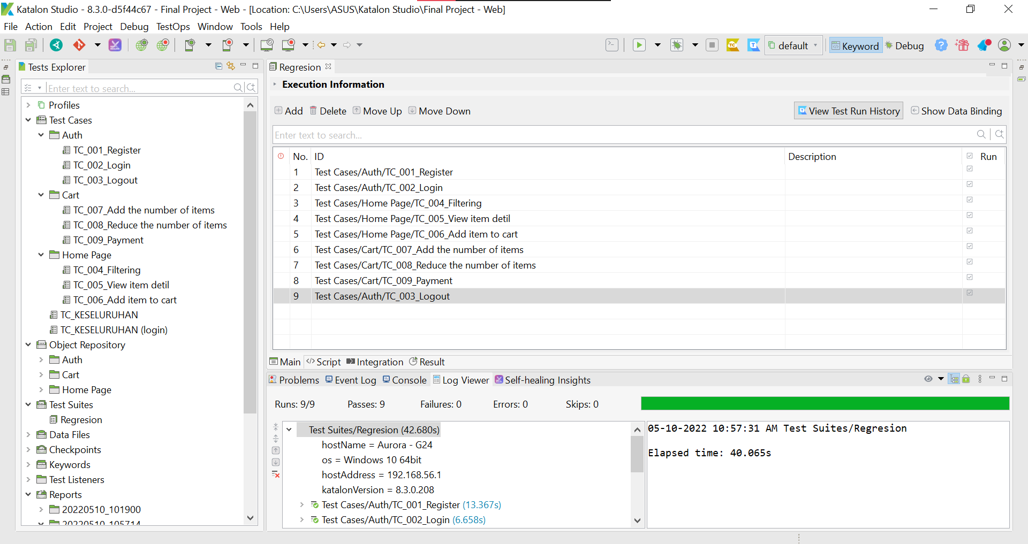

Bug Reports :

| Scenario | Pass | Failed | Skip | Notes |
| --- | --- | --- | --- | --- |
| Authentication |  |  |  |  |
| - Register | √ |  |  |  |
| - Login | √ |  |  |  |
| - Logout | √ |  |  |  |
| Home Page |  | √ |  |  |
| Cart |  | √ |  |  |
| Transaction |  |  | √ | unable to perform automated tests because this feature is unstable. |

**Results and conclusions :**

1. Test result difference on automation testing

**(Test 1)** There are differences in test results between manual and automatic tests on the payment feature.

* manual testing : Unable to display automatic item data on transaction page (FAILED).
* automation testing : Successfully to display item data on transaction page (PASS).

**(Test 2)** There is a change in the test report results on the payment feature.

* manual testing : Unable to display automatic item data on transaction page (FAILED).
* automation testing : Unable to display automatic item data on transaction page (FAILED).

1. Does not perform automated testing on the transaction feature because it is unstable.
2. There are failed results on the filtering feature and unstable on the payment feature. So that if the test automation is re-run, it is likely that the results will be different (there is an error).

**Rest API Testing**

1. Manual Testing

Dokumen test case : <https://bit.ly/3yuTNnB>

Bug Reports :

| Scenario | Number of TC | Pass | Failed | Pending | Notes |
| --- | --- | --- | --- | --- | --- |
| Categories | 4 | 4 | - | - | As expected |
| Products | 6 | 6 | - | - | As expected |
| Authentication | 4 | 4 | - | - | As expected |
| Transaction | 4 | 4 | - | - | As expected |
| Ratings | 4 | 3 | 1 | - | Response code 200 OK successful operation but display data with different ratings with input |
| Comments | 4 | 4 | - | - | As expected |

1. Automation Testing

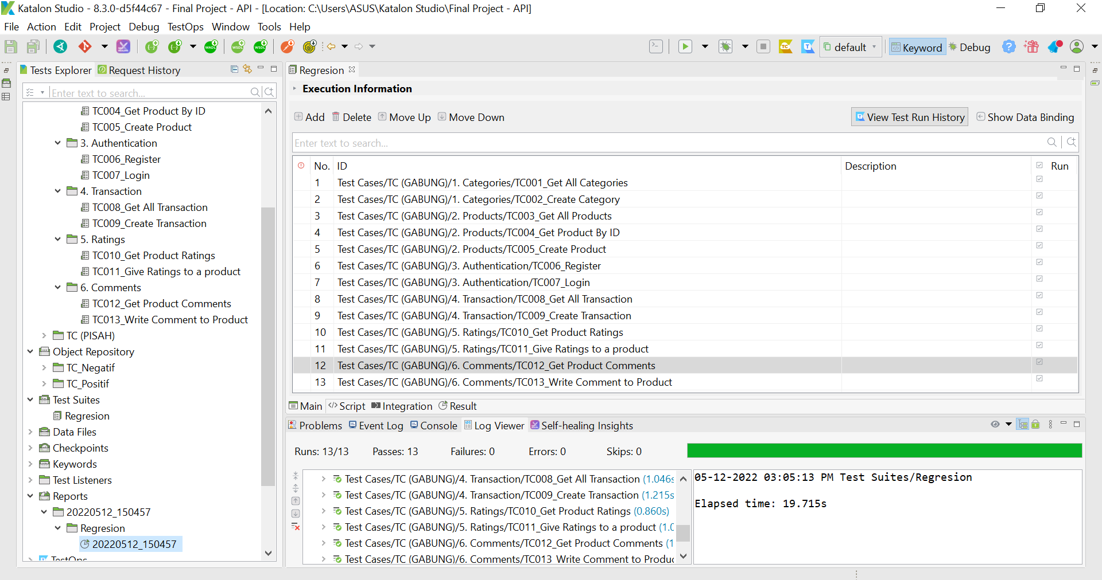

Bug Reports :

| Scenario | Pass | Failed | Skip | Notes |
| --- | --- | --- | --- | --- |
| Categories | √ |  |  |  |
| Products | √ |  |  |  |
| Authentication | √ |  |  |  |
| Transaction | √ |  |  |  |
| Ratings | √ |  |  |  |
| Comments | √ |  |  |  |

**Results and conclusions :**

* 1. The results between manual testing and test automation produce the same report.
  2. For the feature of give a rating to the product when testing results in a response code of 200 OK, but the data displayed does not match what was inputted (FAILED), even if the test automation is successful (PASS).
  3. The product id is always changing so if the test is rerun it will fail.

**Mobile Testing**

1. Manual Testing

Dokumen test case : <https://bit.ly/3yuTNnB>

Bug Reports :

| Scenario | Number of TC | Pass | Failed | Pending | Notes |
| --- | --- | --- | --- | --- | --- |
| Authentication | 15 |  |  |  |  |
| - Register | 7 | 2 | 5 | - | 5 out of 6 negative test case not as expected |
| - Login | 7 | 6 | 1 | - | Successfully logged in using a negative test case |
| - Logout | 1 | 1 | - | - | As expected |
| Home Page | 1 | 1 | - | - | As expected |
| Cart | 1 | - | 1 | - | The cart button on the feature doesn't work |

1. Automation Testing

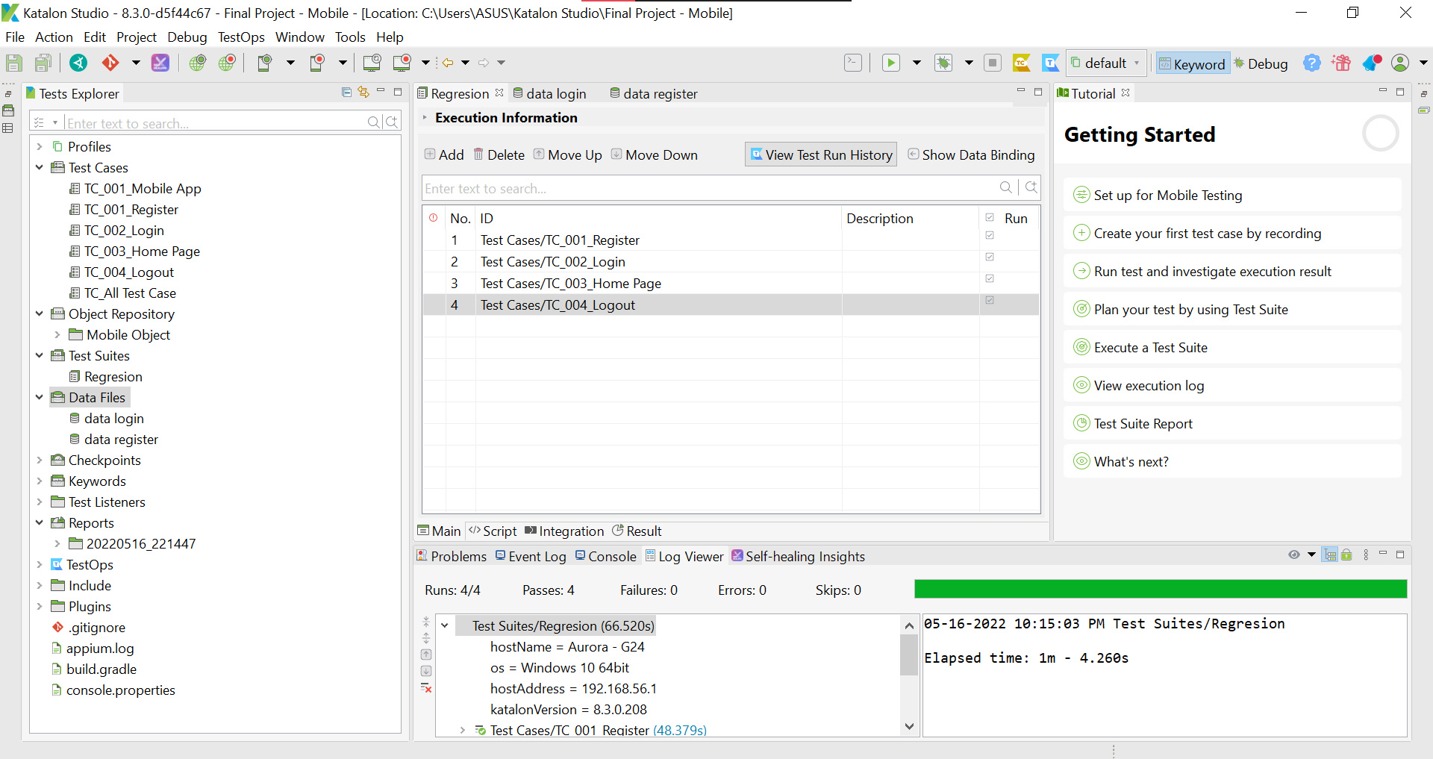

Bug Reports :

| Scenario | Pass | Failed | Skip | Notes |
| --- | --- | --- | --- | --- |
| Authentication |  |  |  |  |
| - Register | √ |  |  |  |
| - Login | √ |  |  |  |
| - Logout | √ |  |  |  |
| Home Page | √ |  |  |  |
| Cart |  |  | √ |  |

**Results and conclusions :**

1. In the login feature there is a bug where you can login with an email and password that contains spaces.
2. Automation testing has been carried out, but there is still a bug in one of the features so it is skipped.

* There are feature that can't work (cart button).

1. No object element to verify.